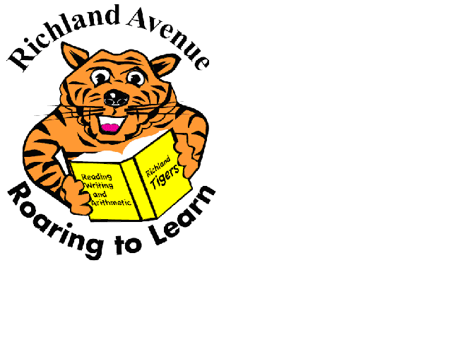
Richland Avenue Elementary
School for Advanced Studies
11562 Richland Ave., Los Angeles, California 90064
Telephone (310) 473-0467; Fax (310) 268-7948

 | November 2020
Sun | Mon | Tue | Wed | Thu | Fri | Sat
1 | 2 | 3 | 4 | 5 | 6 | 7
8  Parent/ Teacher Conference Week | 9  Parent Council  6pm | 10 | 11  School Holiday | 12  Booster Meeting  6 P.M.  via Zoom | 13 | 14
15  Parent/ Teacher Conference Week | 16 | 17 | 18 | 19 | 20 | 21  Canned Food Building Project  at St. Andrew’s Church
22  No school all week | 23 | 24 | 25 | 26  Thanksgiving | 27 | 28
29 | 30  Coffee with the Principal, 11 am

